

A Study of the Synchronisation and Concurrency Issues in the Dining Philosophers’ Problem completed using the ThreadMentor Visualisation Tool

Joseph Tierney: B00092923
Nikolaos Vourdanos: B00093003
Jessica Tati: B00085922
Adam McCarthy: B00085376

Table of Contents
1. Introduction 3
1.1 Tools of Synchronising Processes/Threads in an OS 3
1.2 The Dining Philosophers’ Problem 3
2. Thread Mentor 5
3. Our Solution 5
4. Results and Analysis 7
5. References 8

1. Introduction

1.1 Tools of Synchronising Processes/Threads in an OS
Mutual exclusion, often shortened to mutex, prevents simultaneous access to a shared resource [1]. This is used with a critical section, this is a piece of code that threads access a shard resource with. Mutex works when two threads begin to work on the same data at the same time as each other – this in turn, makes mutex act like a lock. If a thread attempts to access a mutex while it is currently unavailable, the thread is set to sleep and must wait until the mutex is “unlocked” and will acquire the mutex when it is available.

Semaphores can provide an add on to mutexs. A semaphore is a variable that is used for controlling access to multiple threads or processes. Semaphores ensure mutually exclusive access to shared variables. Semaphores allow you to allow a set number of threads through, whereas mutex only allows one thread through.

A monitor is a collection of procedures, variables, and data structures grouped together [2]. Monitors provide automatic mutual exclusion to the variables it encapsulates. These variables can only be accessible by the monitor access procedures which are critical sections, this means that only a single thread may be executing inside a monitor at any given time.

1.2 The Dining Philosophers’ Problem
The Dining Philosophers problem is a classic synchronization problem in operating systems synchronization. It first originated from the mind of Edsger Dijkstra in 1965, originally as an exam exercise for students, presented in terms of “computers competing for access to tape drive peripherals” [3]. Not long after Edsger Dijkstra had presented the original version of the problem, Tony Hoare gave the problem its present form.

The Dinning Philosophers’ Problem is often used as a model for understanding the methods of concurrent programming. Each fork (chopstick) is represented as an object (left, right). As soon as a philosopher picks up a fork (chopstick) then the fork is locked so that he excludes the next philosopher from requesting access to it. To explain it in detail there are some philosophers who sit on a round table and their only purpose is to talk and eat. Every philosopher to eat needs to use the two forks on his right and left. If a philosopher picks up a fork, then he does not leave it until he gets the other, so that he is able to eat. Then he leaves down both forks and waits until he gets hungry again. Demonstrating this problem can be easy. For example: can every philosopher first take the fork on his left and then wait to take the fork on his right. If every philosopher takes the fork on his left all forks are locked and none of the philosophers can successfully lock his right fork (chopstick) [4] On account of, we have circular waiting (where each philosopher is waiting for the right fork but the right fork is occupied by the neighbour philosopher) and this is the biggest problem of the program that results to deadlock. Another problem that might occur is starvation. Starvation in operating systems is when a thread is not able to access a shared resource and is unable to make any progress. This occurs when the resources are being used for long periods by other threads, thus making them unavailable [5].

A group of philosophers (processes) needs to be tuned to have access to a number of forks (pores). The number of philosophers is the same as the number of forks (chopsticks) and each philosopher needs two forks to dine. Access to the forks should be organized to avoid deadlock and starvation. If every philosopher picks up from a fork then we have a dead end. To avoid this situation every philosopher has to lift both of the forks individually. This individuality is accomplished by applying an individuality restriction to the pickup methods of each fork. So a synchronizer (threads) that will show the sequence where each philosopher should pick up a fork.

Our chosen solution for the Dining Philosophers problem is basic mutex. This solution involves the use of Mutex locks. Mutex is defined in class Mutex and has two methods, these methods are Lock(), which acquires the mutex, and Unlock(), which is used for releasing the mutex.

This report will look at, in detail, the ThreadMentor program and its user interface, our chosen solution, what the differences between our solution and the native solution are, and the advantages and disadvantages of our solution. This report will then discuss the results and analysis of the solution, describing the start, middle and end of the program.

2. Thread Mentor
ThreadMentor is a multi-platform pedagogical tool, this means it is a program that people use to learn and/or teach and it is also compatible with more than one form of operating system or computer. It was constructed in order to simplify the learning and teaching of multithreaded programming. The system consists of two components, a visualization system and a class library. The visualization system displays each synchronization primitive in execution and also the control information of them on the fly. Whereas the class library supports many of the thread management functions, these functions consist of thread termination, creation and the joining of threads. Events can be played back as they can be saved. This allows the user to visualize the threaded programs dynamic behaviour and also visualize the interaction among threads and synchronization primitives. It also supports the like of semaphore, monitors, mutex locks, read-writer locks, barrier and synchronous & asynchronous channels (all popular synchronization primitives). The user doesn’t need to concern themselves with the visualization system, the just have to focus on writing the threaded program, they do this by using the class library. The visualization system is activated when the program begins running, as long as it was compiled with the library which includes the visualization system. However, if the user compiles the program with the library that doesn’t include the visualization system, then the program is just a threaded program with no visualization available. As a result, this means that if the user wants to utilise the visualization system is determined by which library the user is using. ThreadMentor is capable of running on Linux, Windows and Sun Solaris. During this project we focused on using ThreadMentor on Linux.

3. Our Solution
Our chosen solution for the Dining Philosophers problem is basic mutex. This solution involves the use of Mutex locks. Mutex is defined in class Mutex and has two methods, these methods are Lock(), which acquires the mutex, and Unlock(), which is used for releasing the mutex. In the Dining Philosophers problem solution, the chopsticks that each philosopher will use to eat will be locked and unlocked. Each chopstick will be numbered, either counter clockwise or clockwise, for instance, if the chopsticks are numbered counter clockwise, philosopher i, his left chopstick is i and the one on his right is i+1. A philosopher will then think for a while, and by calling the method Chopstick[No]->Lock() , will lock the chopstick on his left, and then he will lock the chopstick on his right by calling a similar method Chopstick[(No+1) % PHILOSOPHERS] -> Lock(), in this case, No being the number of the philosopher. The philosopher eats for a while before unlocking the chopstick on his left with the method call Chopstick[No]->Unlock() and then unlocking the chopstick on the right, completing one thinking-eating cycle.

A more concurrency solution is Chandy/Misra that don’t allow the philosophers to starve. In Chandy/Misra solution is whenever a philosopher is hungry he asks his neighbour for a fork and the philosopher that is currently using the fork cleans it and sends it over to the neighbour that asked. The difference between our chosen solution is that the philosopher does not communication in contrary to the Chandy/Misra solution where they must communicate to communicate. For every pair of philosopher that shares a fork (shared resources) is given a lower id whereas to our chosen solution we give numbers to our philosophers. When a philosopher using the mutex lock for the fork is hungry he unlocks his fork so he can eat in contrary to the Chandy/Misra solution where a philosopher asks his neighbour for a fork to eat. The Chandy/Misra solution uses an std::condition_variable that helps enable the blocking of the thread classes.

The advantages of our chosen solution are resource starvation which is a feature of deadlock which controls the timing so that the philosophers aren’t all picking up their chopsticks at the same time to start eating. The resource starvation avoids the deadlock state so that they will be able to pick up the chopsticks in a certain time given. Fredrick Kennard (2015 p236) explains that [6] resource starvation might also occur independently of deadlock if a particular philosopher is unable to acquire both forks because of a timing problem.Top of FormBottom of Form Resource starvation helps avoid deadlock which allow some philosophers to starve.

The disadvantages are the livelock which allows all philosophers to perform acts such as sitting down, picking up chopsticks, eating and thinking all at the same time then wait for a certain time until they must repeat these acts again, the philosophers will suffer. Mutual exclusion is used to create a generic that can arise problems in the real-life computer programs when [7] multiple programs need exclusive access to shared resources (Fredrick Kennard 2015).

4. Results and Analysis
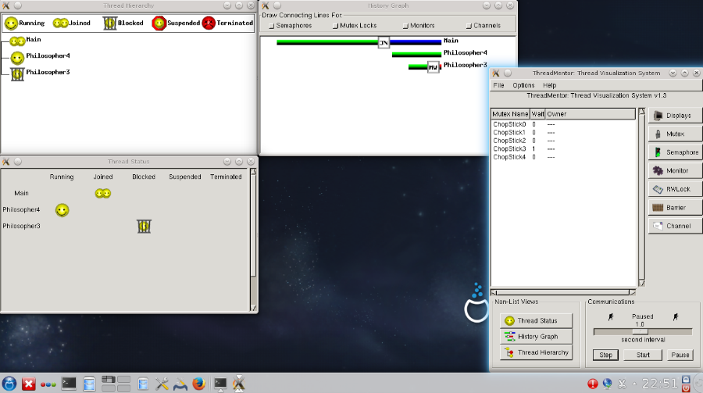

From the screen shot from above we notice in the history graph window main thread is joined. Philosopher 4 is not doing anything and Philosopher 3 is trying to pick up the chopsticks. Philosopher 3 is blocked whilst philosopher 4 is still running.

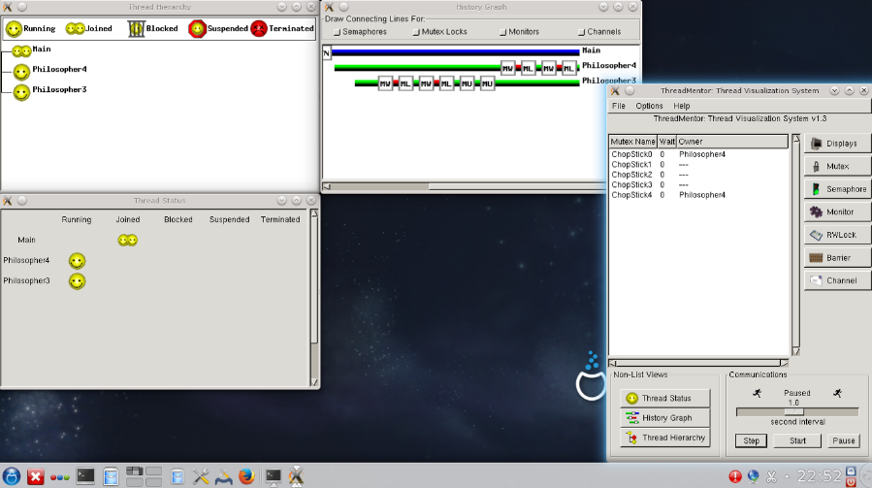

In the middle stage, we can see that philosopher 4 and 5 are running and from the ThreadMentor Philosopher 4 has hold of the chopsticks. The philosopher 4 locks in the chopstick so its neighbours won’t pick it up.

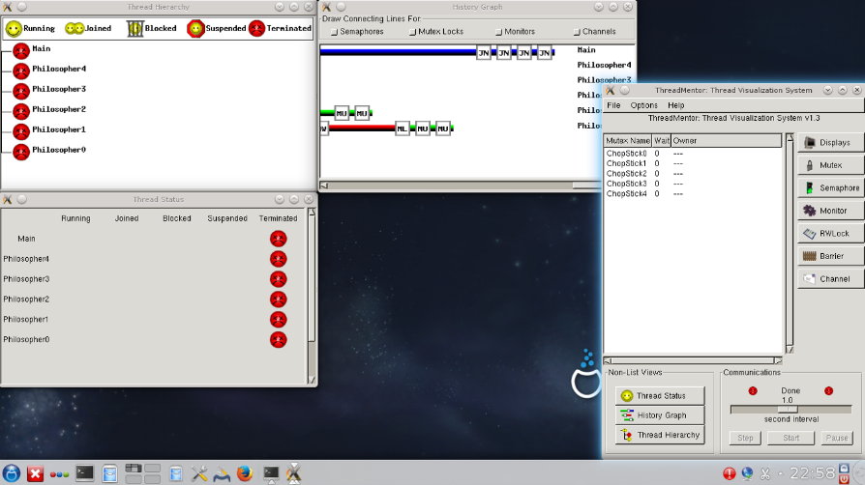

From the screenshot above, we are fully aware that this is the final stage where all philosophers finished their thinking-eating cycle.

5. References
[1] "What Is Mutual Exclusion (Mutex)? - Definition From Techopedia". Techopedia.com. N.p., 2017. Web. https://www.techopedia.com/definition/25629/mutual-exclusion-mutex

[2] "CS 3733 Operating Systems Notes: Monitors". Vip.cs.utsa.edu. N.p., 2017. Web. http://vip.cs.utsa.edu/classes/cs3733f2004/notes/Monitors.html

[3] Dijkstra, Edsger. "EWD-1000". Web. http://www.cs.utexas.edu/users/EWD/ewd10xx/EWD1000.PDF

[4] ThreadMentor: The Dining Philosophers Problem
https://www.cs.mtu.edu/~shene/NSF-3/e-Book/MUTEX/TM-example-philos-1.html

[5] "Starvation And Livelock (The Java™ Tutorials > Essential Classes > Concurrency)". Docs.oracle.com. N.p., 2017. Web.
https://docs.oracle.com/javase/tutorial/essential/concurrency/starvelive.html

[6] Thought Experiments: Popular Thought Experiments in Philosophy, Physics, Ethics, Computer Science & Mathematics.

[7] Thought Experiments: Popular Thought Experiments in Philosophy, Physics, Ethics, Computer Science & Mathematics

